**DANGORIA CHARITABLE TRUST**

**ANNUAL REPORT**

**2020-2021**

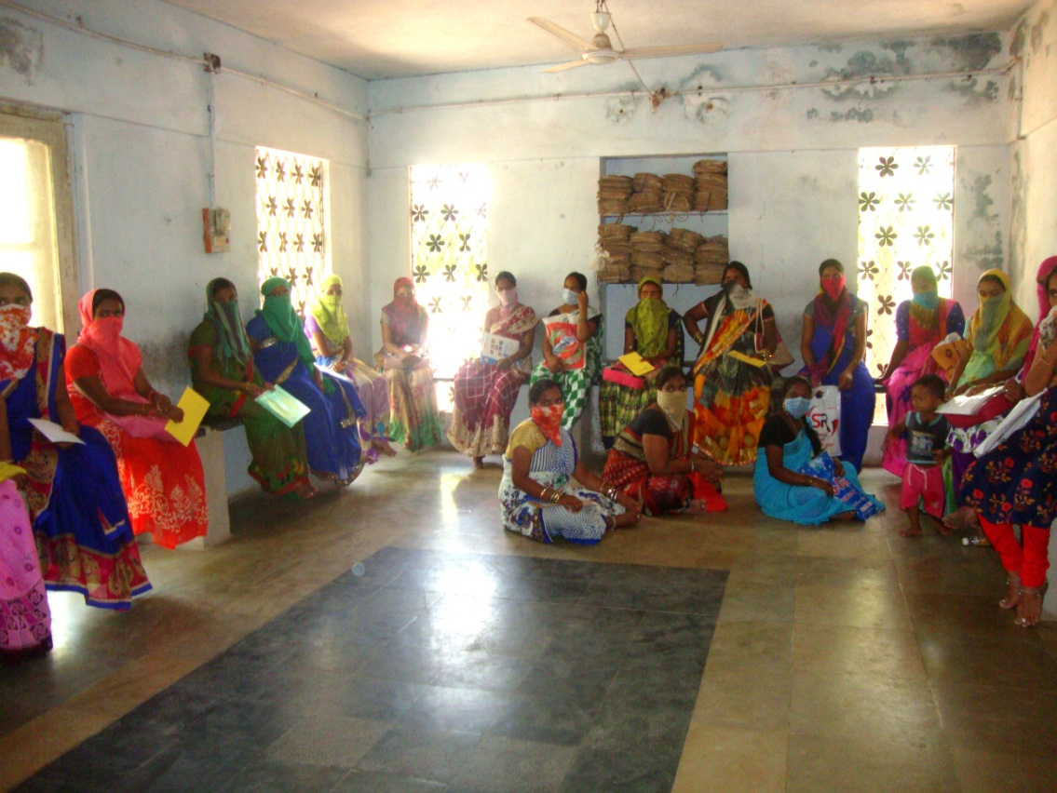

**Women with mask and social distancing in the outpatient department of**

**the Dangoria Charitable Trust hospital in Narsapur**

**Address for Correspondence**

Dangoria Charitable Trust

1-7-1074, Musheerabad, Hyderabad, 500020.

Telephone: 040-27661422, 27615482

Rural Centre: DangoriaHospital for Women and Children,

Village Narsapur, Medak district, Telangana

Telephone: 08458-287841, 08458- 286241, Cell: 9490609867

Email: dangoriatrust@yahoo.com

Web Site: www. dangoriatrust.org.in

**CONTENTS**

|  |  |
| --- | --- |
| **Subject** | **Page** |
| Acknowledgements | 3 |
| Staff | 4 |
| Honorary consultants | 5 |
| Introduction | 6 |
| Hospital –based activities | 6 |
| HIV Screening of pregnant women | 6 |
| Tara Lakshmi Home for the Aged   |  |  | | --- | --- | | MahilaUdyog .Food processing and training  Rural hub for promoting Food and Nutrition Security  PilutlaSthreemandal-wicks making  Tailoring and embroidery classes  Participation in conferences and meetings  Visitors  List of donors | 15-17 | | Photographs | 18- | | 7  7  8  11  11  11  12  13  14 |

**ACKNOWLEDGEMENTS**

The Dangoria charitable Trust is grateful to the following for their varied contributions.

1. All the donors, (particularly Dr Cyrus Mehta, CYTEL, USA) who have contributed in cash or kind, for their support.
2. National Academy of Sciences India(NASI), Prayagraj-211 002 for financing the project ,”Rural hub for promoting food and nutrition security in a tribal (Banjara) community of Narsapur mandal, Medak district, TS

3. LV Prasad Eye Institute, Hyderabad, for free eye check-up and treatment of the members of the Home for the aged.4.

4. Dr.Janardhan Rao,.(radiologist) and Dr.Neelam Reddy (anaesthetist) for professional help during clinic days at Narsapur.

Hon. Consultants mentioned on page 5 for technical advice

1. Dr. K Veena Kumari, MBBS, DGO, Retd Commissioner, Telangana, Vaidya Vidhana Parishad, for helping with surgeries during emergency
2. Dangoria Hospital, Hyderabad for medical and material support. Geet Medical shop for facilitating supply of drugs.
3. Rajendra Tapadia (Genesis InSoft Limited and Trustee) for managing the web site at no cost, and also paying for Go Daddy paid site.
4. R.K. Bang and Co. Chartered accountant for auditing the accounts of the trust and for advice and Mr. M. Patti, Chartered accountant for auditing the project accounts.
5. Jawahar Associates for help in loading FCRA accounts statements.
6. Food Safety Designated Officer, Medak District,,Hqs .Sangareddy for issuing licenses for food products.
7. Raj Flavours, Hyderabad, for interest and help in procuring material for food processing
8. Sri Rajgopal Tapadia for annual ice cream party for members of the Home for the aged, and staff
9. Some **r**esidents of Home for the Aged- for helping with kitchen supervision and kitchen work.
10. R.S.N.Sastry for maintaining Trust accounts

**STAFF**

**Physicians, scientist**

DevyaniDangoria, MBBS, DGO, DRCOG (Lond.) (Hon) Managing Trustee and

Physician in Charge (Hon)

Mahtab S. Bamji, MSc, Ph.D, FNA, FNAAS,FAMS, INSA Emeritus Scientist,

and Trustee (former Director grade Scientist, NIN, Hyderabad). (Hon)

R. Shanti MBBS, DGO Hon. Gynaecologist

N SwarnaLata, MBS (Homeo) Resident Medical Officer

K. Lakshmi, BAMS Hon. Physician

P.V.V.S.Murthy, M.A (Social Work),M.A (Sociology) Senior Investigator

**Technical and nursing staff**

B. Nagamani, B.Com., MSW., DMLT., Lab Technician

G. Neeraja, N. SwapnaB. Anitha ANM

B. Bhashamma, Nursing assistant

E.VijayalaxmiHospital assistant

B .Nagalaxmi, B Com, B Ed Supervisor

**Project technical staff**

N. Venkatesh Vocational diploma in Agriculture, Technical assist - Horticulture

K.V.Lakshmi ,M.A.,B.Ed.,Certificate Course in food and nutrition, Project assistant

Radha and Balamani Food processing

**Supporting staff**

B.Nagesh, , , A Ramu, Drivers

Y.Kalavathi, Y.Swarupa, Hospital ayahs

B..Chandrakala,,B.Vijayalaxmi Cooks-Home for the aged

K.Rani, A.Yadamma, B.Narsamma, P.Sujata ,K.Susheela ,

Surekha ,B. Narsimlu, B. Krishna, Helpers, Home for the aged

K. Balamma ,R.Gangamma, Gardners

P. Raju,,P.AnjaneyuluDhobhi

J. Jyothi, J. Anasuya,Sweepers

**HON. CONSULTANTS FROM S&T INSTITUTIONS:**

Scientists from foll. Institutions have participated in training programmes as resource persons :

1. **Health and Nutrition**: ICMR National Institute of Nutrition, Hyderabad

Dr.G.MSubbarao,.Dr .A .Lakshmaiah

2.**Agriculture E**kalavya Krishi Vigyan Kenddra, Tuniki, Medak District, Dr.G.Syamasundar Reddy, consultant and former Sr. Scientist and Head, Scientists Sri. K. Murali Mohan (Soil science), Sri. M. Srinivas (Horticulture), P. Ravi (Entamology)

3. **Backyard poultry and supply of birds:** Dr.K.Kotaiah , Indbro Research and Breeding Farms Ltd.,Hyderabad.

**Statistics:** Ms Parimala Diana Sudhir, Head, Department of Statistics, Aurora College, Hyderabad.

**INTRODUCTION**

The overall objective of the Dangoria Charitable Trust DCT), is to provide affordable Maternal and child health service; care of the elderly and empower the community with education, training and capacity building, in the area of food, nutrition, health and environment. Since its inception in 1981 DCThas been running a 20 bedded hospital for women and children in village Narsaur, Medak district of Telangana State, India. A home for the aged was started in 1995 and currently houses 40 elderly-women and men. Since last 25 years DCT has extension activities in select villages of Narsapurand surrounding*mandals* of Medak district, TS, in the area of Health, Food & Nutrition and, Environment and runs a Food processing cum training centre under MahilaUdyog Women’s development society. Tailoring and embroidery classes are run for girls to facilitate employment generation.

**HOSPITAL BASED ACTIVITIES**

On every Tuesday and Friday a medical team consisting of doctors, from the Dangoria Hospital for women, Hyderabad, some other physicians, and a technician visit the Narsapur hospital to conduct the out- patient antenatal clinic and obstetric/gynaec surgeries. On Tuesdays, a paediatrician also used to accompanies the medical team. But during this period no paediatrician could come due to COVID-19.

From April 2020, to March 2021, 1316 cases were registered. 261 deliveries, including 128 caesarean sections, 109 tubectomies, 14 PNS, 04 MTP were done. Immunizations are done on every first Tuesday of the month during the paediatric clinic. In recent years demand for the hospital has decreased, due to an upgradation of the government hospital in Narsapur and incentives to pregnant women for deliveries in government hospital.

The incidence of Low birth weight (< 2.5 Kg) was, 15.7%. is much lower than the national average of 20%.

**Ambulance Service**

DCT runs an ambulance service to take patients to the city hospital(s).

**HIV screening of pregnant women**

All antenatal cases are screened for HIV/AIDS infection. The infected women are treated free of cost to prevent mother to child transmission of infections. During the reporting period, April 2020 to March 2021 out of total 1147 antenatal cases registered, 842 cases were tested for HIV infection. There were no HIV positive cases.

**TARALAKSHMI HOME FOR THE AGED**

This home was started in 1994, to cater to the needs of elderly women and men. About 40 resource- poor elderly including couples reside in the home. During the year 8 members (3 men and 5 women) all old and ailing passed away. New members have taken their place.

**MAHILA UDYOD, FOOD PROCESSING CUM TRINING CENTRE**

*Mahilaudyog* continues to run food processing cum training centre. Table 1 gives the list

Of products being prepared in the centre.

**Table 1 List of food products produced and marketed**

|  |  |
| --- | --- |
| Poshana- a Cereal pulse complementary food | Chutney powders from solar-dried curry leaves, mint leaves, gongura(Hibiscus) leaves |
| NutriMix- A multigrain complementary food | Lime pickle, Mango pickle, *Dosakaya*(Cucumis sativas) pickle |
| Ragi(finger millet) malt(sprouted roasted ragi-finger millet) | *Putnala*(Roasted Bengal gramdal) *podi* |
| Instant multigrain dosa | Lime squash, Orange squash, |
| *Ragiladdu* | Mango squash, mango bars |
| Multigrain millet biscuits | Maize chudwa ( a savoury snack) |
| Tomato pickle(solar dried), | Popcorn |
| Tomato sauce | Sambar powder |
| Tomato puree | Rasam powder |

Institutions like LV Prasad Eye institute, Hyderabad Eye Institute, Bhubaneswar, Institute of Rural Health Studies, Ramakrishna Mission’s health centre and Dr. Fernandez hospital (an Obstetric-gynaec and paediatric hospital) purchase nutritious foods like the cereal –pulse mix, Poshana and ragi malt for selling or giving to women and children. One entrepreneur from Hyderabad buys variety of products like Poshana, ragi malt, Nutrimix, and multigrain biscuits for marketing in Fernandez hospital canteen. The Centre for Cellular and Molecular Biology (CCMB), and Indian Institute of chemical technology (IICT) Hyderabad, buy `sambhar’ powder for their canteens but this year no purchase order were place due to COVID –19 and canteens not running. Fernandez Hospital has started its central kitchen at Madhapur and given order to MahilaUdyog for supply of various products, particularly pickles in bulk quantities. One shop in Hyderabad sells multigrain biscuits.

The millet based products like - iron and zinc fortified cereal-millet complementary food –Nutrimix, and multi-grain biscuits developed in this project have low glycaemic index and are suitable for diabetics.

**RURAL HUB FOR PROMOTING FOOD AND NUTRITION SECURITY**:

The purpose of the Hub is- wider dissemination of the model of Nutritionally sensitive and environmentally sustainable farming, and backyard poultry with high egg yielding birds, developed in the earlier projects along with behavioural change communication in the area of health, nutrition,, and environment. A batch of 5 villages is covered over a period of six months -one month for contact with the community, and initial survey, four months for transfer of farm technologies and education (behavioural change communication), and one month for final impact evaluation. Families with pregnant woman and/ mother with 6 to 24 months old children are preferably targeted. Educational interventions were done through focus group discussions and centralised and de-centralised, hands-on training. Teaching aids included simple messages through pamphlets. Impact assessment is done by assessing the acceptance of farm technologies, and knowledge attitude, practice (KAP) surveys of the mothers with 6-24 months old children, to assess the impact of education.

A Project on “Rural hub for promoting food and nutrition security in tribal (Banjara) community “ was started on 1st June 2020 with the financial support from National Academy of Science India(NASI), Prayagraj.The objectives were:

General:

To create a rural hub for promoting Food and Nutrition security, through technological and social engineering in a tribal community.

**Specific objectives**

To organize training programmes in the following aspects along with awareness generation, Behaviour Change Communication (BCC) for wider outreach of strategies developed by DCT towards food and nutrition security

* Nutritionally sensitive and environmentally sustainable agriculture to increase access to micro nutrient (vitamins &minerals)-dense foods (partial crop diversification, from water- intensive crops like paddy and sugar cane to micro-nutrient dense crops like vegetables, fruits, millets and legumes).
* Organic methods of farming like vermicomposting and use of botanical pesticides.
* Backyard poultry with high -egg -yielding strains of birds.
* Training women in food processing- value addition to farm produce and preparation of low-cost nutritious foods for complementary feeding
* Behavioural change communication in aspects of health, food nutrition, water, and sanitation, and common infectious diseases, their causes and remedies.

13 tribal (lambada) settlements ( approximate population 3000 ) covering Four Gram Pamchayats( 1.Madapur 2. Mohammadabad 3. Yellareddytanda 4. Pilligundlatanda), in Narsapurmandal of Medak district in the South Indian state of Telangana

132 vegetable gardens were raised diverting, 28.65 acres of land from traditional water guzzling crops like paddy and sugar cane to raising vegetables, pulses and millets.

Sixty one families, set-up backyard poultry by purchasing 5 birds at the rate of Rs300/- each.

.

**Impact on mothers’ knowledge of health and nutrition**: KAP surveys of mothers with 6-24 months old children done initially and end line showed positive impact on crops grown and remarkable improvement in the mothers’ knowledge regarding maternal and child health, and food and nutrition (Table 2) suggesting good impact of education. Following are some of the findings

1. All the women and men had studied at least up to 7th class and some more.
2. All respondents except one had own land, but the holdings were marginal –less than 200 guntas (5 acres)
3. Water source for farming was bore well and rain water when the bore well dried up
4. All the respondents reported diverting a small patch of land (average 10 guntas- 0.25 acres) for growing vegetables and fruits. ( Table 2).
5. There was significant increase in the number of households growing pulses and millets also. (Table 2).
6. Only 6 women reported setting up vermicompost beds in the end -line survey
7. Many women reported using neem and chili-garlic –based botanical pesticides in the end- line survey.
8. Only few women reported having poultry or dairy.
9. All most all women had undergone at least 6 antenatal check-up in both the surveys
10. All the women in both the surveys reported consuming iron folic acid tablets during pregnancy, but only about 70% in both the surveys had consumed it regularly during the previous pregnancy. (Table 2)
11. Ninety percent women in both the surveys mentioned initiating breast feeding within 1 hour after birth. (Table 2)
12. Remarkably, over 90% women in both the surveys mentioned initiation of complementary feeding by 7 month.
13. There was remarkable improvement in the mothers’ understanding of health, food and nutrition including care during pregnancy, food taboos during pregnancy, child feeding practices, components of balanced diet, nutrients in foods and their functions and common infectious diseases, their causes and remedies . ( Table 2)
14. Table 3 shows that vegetable consumption, showed significant increase
15. Indebtedness was almost universal. Most loans were taken either from the bank or DWCRA. Very few women mentioned taking loan from money lander.
16. Most women had experienced loan waiver and support from the Telangana Government’s scheme “Rythu bandhu”

**Table 2 Initial and end line KAP Survey- % of respondents**

|  |  |  |
| --- | --- | --- |
| **Question** | **Initial- %** | **End-line - %** |
| Growing vegetables and fruits | 34 | 96*** |
| Growing pulses | 48 | 88*** |
| Growing millets | 78 | 92** |
| Having BYP | 8.0 | 16.0 |
| **Food consumed during pregnancy and food taboos** | | |
| More food during pregnancy | 10 | 84*** |
| Papaya avoided during pregnancy  through fear of abortion | 100 | 74*** |
| Banana avoided during pregnancy through fear of single child infertility, since banana tree fruits only once | 94 | 58*** |
| Regular consumption of iron folic acid tablets | 76 | 70 |
| **Cooking Practices** | | |
| **Do not** discard excess water (*ganji)* after cooking rice. | 6.0 | 100*** |
| Wash vegetables before cutting | 4.0 | 100*** |
| **Infant and child feeding practices** | | |
| Initiate breast feeding within one hour after birth | 90 | 92 |
| Initiate complementary feeding at 7 month of age | 92 | 98 |
| **Items in complementary food-Mothers’ knowledge** | | |
| Rice | 100 | 100 |
| Dal (lentil gruel) | 44 | 42 |
| *Roti* ( salty pancakes made from cereals or millets | 8.0 | 32** |
| Milk and milk products | 100 | 70 |
| GLV | 38 | 98*** |
| Vegetables | 28 | 50** |
| Egg | 72 | 86*** |
| Yellow of egg fed. ( normally discarded) | 62 | 94*** |
| Hand washed with soap and water | 20 | 100*** |

**Significance: *P < 0.05, **P < 0. 01 *** P < 0.001**

The data suggest that despite inability to hold regular meetings with the women there was positive impact on knowledge attitude and practice and vegetable consumption and the strategy of educating the community through pamphlets in Telugu and involving the *anganwadi*  worker.

**Table 3 Food Consumption by the families**

|  |  |  |  |  |
| --- | --- | --- | --- | --- |
| **Type of Food** | **Frequency of consumption / week** | | **Daily per person consumption- g** | |
|  | **Initial** | **End -line** | **Initial** | **End-line** |
| Rice | 7 | 7 | 418.9 | 481.4 |
| Corn/Jowar/Roti | 6.06 | 5.06* | 110.4 | 79.9** |
| Dal | 2.24 | 2.22 | 15.21 | 16.97 |
| Vegetables | 2.96 | 2.92 | 46.5 | 60.7*** |
| GLV | 2.28 | 2.94*** | 52.2 | 75.7*** |
| Milk & Milk products | 7 | 7 | 75.3 | 67.9 |
| Egg | 1.54 | 1.52 | 10.07 | 12.9 |
| Meat/Fish | 1.18 | 1.1 | 32.4 | 36.4 |
|  |  |  |  |  |

**Significance: *P < 0.05, **P < 0. 01 *** P < 0.001**

**PILUTLA STREE MANDAL**- **Wicks making**

This is an ongoing activity. Women of village Pillutla continue to make and market wicks under PilutlaSthree Mandal. The wicks are being sold in Hyderabad. Monthly sale is

Rs.5000 -6000.

**TAILORING AND EMBROIDERY CLASSES: This** is a continuing activity in which batches of 20-25 girls are taught tailoring to promote livelihood.**Due to COVID-19 the centre was temporarily closed.**

**PARTICIPATION IN MEETINGS, CONFERENCES**

|  |  |
| --- | --- |
| **Mahtab S Bamji** | **Meetings** |
| **Physical participation** |  |
| March 8, 2021 | JVV, Vignan Darshni, women’s day- lecture |
| March 6 2021 | IRHS, GB Meeting |
| March 14,2021 | SAIRD, Board meeting in Gaddepalli |
| **Virtual Webinars, meetings** |  |
| **June 23rd, 2020** | IWSA GB meeting |
| August 5, 2020 | IWSA lecture. Food and nutrition security are vital for India’s development |
| August 6,2020 | Aurora degree and PG college, Board meeting |
| August 4 -9, 2020 | MSSRF Virtual consultation Science for Resilient Food, Nutrition and Livelihoods: Contemporary Challenges” |
| Sept.22,2020 | NASI India –INSA . Nutrition in the times of pandemic  Key note address |
| November 7, 2020 | IWSA Hyderabad GB Meeting |
| December 11, 2020 | CDFD Ethics committee meeting |
| December 14, 2020 | INSA, GB Meeting |
| Deceember 15,2020 | NSI, Annual GB Meeting |
| January 16,2021 | NAAS Hyderabad chapter meeting |
| January 7, 2021 | NIN facilities inauguration |
| February 27, 2021 | Aurora college, GB meeting |
| March 16, 2021 | IRHS GB Meeting |

**VISITORS**

During the year, following visitors came to DCT Centre in Narsapur, Medak District.

1. November 27, 2020-A Six member team of AIC-CCMB, Hyderabad for a study of the inmates of the Home for the Aged, DCT
2. January 06, 2021- Ramesh Jain ,Vice President, Mytrah Energy, Gachibowli, Hyderabad
3. March 22, 2021 – B.Srinivas, Sangareddy, Raampet
4. March 22, 2021-D.Chinnammai, Daulatabad Sangareddy Dist

**LIST OF DONORS**

|  |  |
| --- | --- |
| Name of the Donor | **Amount Rs** |
| Dr. Leela Raman | 100000 |
| Eshna Dasgupta | 5000 |
| Swaran Pasricha, | 200000 |
| Dr. G. M. Subbarao, | 10000 |
| Vasudev Badrinath | 20000 |
| Perwiz .P.Nalladaru | 5000 |
| Priti J.Bhanushali | 100000 |
| Paurichisti katrak | 10000 |
| Vanka Srinivas | 25000 |
| Vanka Uma | 25000 |
| Dhun Parekh | 10000 |
| Zoriastrian Stree Mandal | 5000 |
| V. Sai Aditya | 2200 |
| Dr. A Lakshmi Prasad | 5000 |
| Dr. Cyrus Mehta ($ 30,000) | 2181000 |
| Shivani Shrof | 25000 |
| A. Lakshman Rao | 10000 |
| Jagan | 20000 |
| Karumuri Srinivasrao | 20000 |
| Piyush Sushil | 5000 |